**FIRST TERM**

**TOPICAL BREAKDOWN**

**1. Location of Uganda on the map of East Africa**

i. The districts that form Uganda. (Revision of the cardinal points & semi cardinal points)

ii. Longitudes and latitudes and latitudes

iii. Uganda's neighbours

iv. Elements of a map

**2. Physical Features in Uganda**

i. Meaning of physical features (Introduction)

ii. Formation of different physical features

iii. Influence of physical features on climate.

iv. Influence of physical features on;

• Vegetation

• Animal and birds *.*

*•* Human beings

Importance of different physical features Problems associated with different types of physical features

**3. Climate of Uganda**

* Climate
* Climate regions of Uganda
* Influence of physical features on climate
* Influence of climate on human activities
* Problems associated with warm and wet areas to living things
* Possible solutions

**4. Vegetation in Uganda**

* Vegetation
* Different types of vegetation
* Factors that influence vegetation distribution
* Different ways vegetation influences human activities
* Uses of vegetation
* Ways of conserving vegetation
* Human activities that negatively affect, vegetation
* Relationship between vegetation

**5. Natural Resources in Uganda**

* The ept of Natural resources
* Different types of natural resources in Uganda ,
* Location of different natural resources on the map of Uganda
* Influence of natural resources
* Problems associated with development of various natural resources
* Care for natural resources

**LOCATION OF UGANDA ON THE MAP OF EAST AFRICA**

New words

Administration,Resource,Natural,Country

**The Districts of Uganda**

A district is the biggest political unit in the country.

Uganda is made up of 135 districts .

**Someof the districts which form Uganda from each region**

|  |  |  |  |  |  |
| --- | --- | --- | --- | --- | --- |
| **NORTHERN** | **SOUTHERN** | **CENTRAL** | **EASTERN** | **WESTERN** | **N.EASTERN** |
| Gulu | Mbarara | Masaka | Mbale | Hoima | Kotido |
| Lira | Ntungamo | Mpigi | Jinja | Masindi | Moroto |
| Kitgum | Ibanda | Mukono | Soroti | Bundibugyo | Nakapiripirit |
| Moyo | Isingiro | Kiboga | Kumi | Kasese | Kaabong |
| Apac | Kiruhura | Rakai | Bududa | Buliisa | Napak |

**Activity**

Children identify the above districts in Uganda using the Atlas.

Exercise

1.Give two reasons why Uganda is divided into districts.

2. Name the two Island districts of Uganda.

3.Who is the political head of a district?

4.What is decentralization?

5. Give any two benefits of decentralization to;

a. the country

b. people

A MAP SHOWING DISTRICTS OF UGANDA

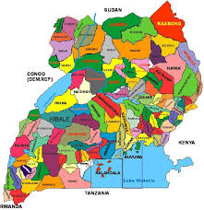

**Activity**

1. Identify your district on the map of Uganda using your atlas.

2. Name the districts neighbouring your district in the following directions

a) North

b) South

c) West East

**Exercise**

1. Name some of the features which form natural boundaries between districts.

2 How is Kampala city important to Ugandans?

3. Name the two Island districts of Uganda.

REVISION OF A COMPASS AND A COMPASS ROSE

A compass is an instrument used to show direction of places.

**A picture of a compass**

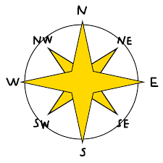

PEOPLE WHO USE A COMPASS IN THEIR WORK

Pilots

Sailors

Tourists

Soldiers

Mountain climbers

Compass Rose/direction

This is an element of a map used to show direction.

**A picture of a compass Rose**

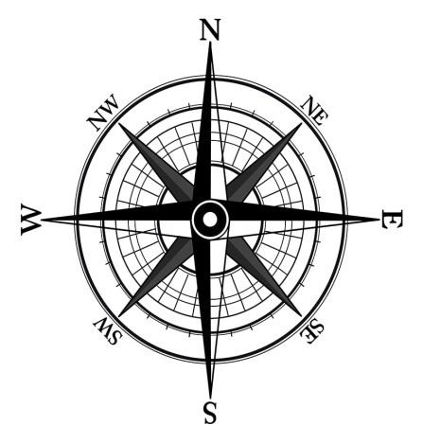

Activity

Take children out to identify directions.

Exercise

1. Give the difference between a cardinal point and a semi cardinal point.
2. State any two examples of semi cardinal points
3. What are semi cardinal points?
4. In which direction does the sun;
5. Rise?
6. Set?
7. In which direction is the sun at 7:00a.m?
8. At what time of the day is the shadow shortest?
9. In which direction is the sun at 5:00p.m?
10. John was going to school in the morning, he saw his shadow on his right. Towards which direction was he moving?
11. What is the direction of Gulu from Kampala?

**Lines of latitude and longitude**

**New words**

**latitude,longitude,imaginary,globe**

**Latitudes**

These are imaginary lines running from East to West of the globe.

**Longitudes.**

These are imaginary lines running from the North Pole to the South Pole of the globe.

**Examples of Latitudes**

a) Equator 0°

b) Tropic of Cancer 23*1/2°* N

c) Tropic of Capricorn 231/2° S

d) Arctic Circle 661/2° N

e)Antarctic Circle 661/2°S

**Lines of Latitude**

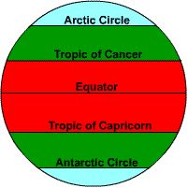

6. When is the sun overhead on the following latitudes?

i. Equator - 21st" March, 23rdSeptember

ii. Tropic of Cancer - 21stJune.

iii. Tropic of Capricorn - 22nd December

**Examples of Longitudes:**

1. Prime meridian / Greenwich meridian. 0°
2. International Date Line 180°

**Lines of Longitude**

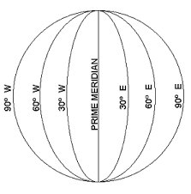

**Exercise**

1. Name the line of Latitude marked 0°
2. Name the line of Longitude marked 0°
3. Why is the prime meridian called Greenwich meridian?
4. Why is the equator marked 0°?
5. Why the prime meridian marked 0°?
6. Name the city in Africa crossed by the prime meridian
7. Give the importance of the prime meridian?
8. How are longitudes and latitudes important to a map reader?
9. Which line of longitude helps to determine days and dates?
10. What is equinox?

**LOCATION OF UGANDA USING LATITUDES AND LONGITUDES.**

Uganda is located between 1°S and 5°N of the equator and 29°E and 35°E of the prime meridian. (Ref: Atlas)

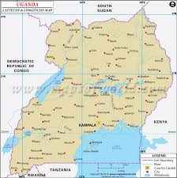

**Activity;**

Children stick the map of Uganda showing longitudes and latitudes.

**Exercise**

1. Name the two lakes crossed by the equator in Uganda.
2. Give the position of Uganda using lines of longitude and latitude?
3. Give the importance of longitudes and latitudes to a map reader.
4. Name the districts of Uganda crossed by the Equator.

**Uganda as a land locked country and her neighbours**

**New Words**

neighbouring,surrounded,landlocked

Uganda has the neighbours below;

• Kenya to the East

• Tanzania to the South

• Rwanda to the South-West

• Democratic republic of Congo to the West

• South Sudan to the North.

**UGANDA AND HER NEIGHBOURS**

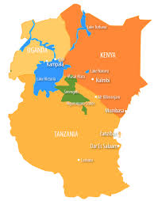

**LAND LOCKED COUNTRIES.**

**New Words**

**seaport,coastline,imports,exports**

1. A landlocked country is a country without a seaport,
2. A country surrounded by other countries

**PROBLEMS FACED BY LANDLOCKED COUNTRIES**

1. Delay of goods on the way.
2. High transport cost.
3. High taxes charged on imports and exports.
4. Lack of privacy.

**EXERCISE**

1. Give the meaning of the words below
   1. Imports
   2. Exports
   3. Smuggling of goods
2. Why is Uganda called a landlocked country?
3. Name the land locked countries which boarder Uganda?
4. Why should smuggling of goods be controlled in a country?
5. Which country lies in the west of Uganda?

**ELEMENTS OF A MAP**

**New Words**

Elements, Representation, Symbols, Drawing

A map is a representation of an object as seen from above,

Elements of a map are the things which help a map reader to understand a map easily.

Elements of a map include;

a) Key

b) Scale

c) Compass rose/direction

d) Title or heading

e) Frame

**A KEY**

It is a table of map symbols and what they represent

A key helps to interpret map symbols.

Map symbols are small drawings that represent real objects

**SCALE**

It is an element that helps to calculate actual distances between places on a map.

**Types of scales**

Linear scales

Statement scales

Fractional scales

**Exercise**

1) Given that 1cm represents 50km.

Calculate the distance between town X and Y. Y is 6cm from X? What type of scale is used above?

2) Use the scale given to calculate the distance between N and M

**TITLE /HEADING.**

1. A title tells what a map is about.
2. A title is written at the top or bottom of a map

**FRAME**

Frames are the lines drawn to enclose a map.

It shows the area represented by the map.

**EXERCISE**

1. In which, direction is Kenya from Uganda?

2. State the opposite direction of south-East?

3. Mention any two groups of people who use a compass in their work?

4. What helps a sailor to find direction of places?

5. John was facing North he turned 45° clockwise. State his new direction,

**TOPIC 2:**

**PHYSICAL FEATURES IN UGANDA**

**Physical features of Uganda**

**New Words**

physical, landforms, Volcanicity, Warping, Depression, Compression, Tensional, Magma, Faulting, Drainage, Relief , Plateau

Physical features are natural, land forms on the earth's surface.

Physical features are grouped into two:-

• Relief features

• Drainage features

3. Examples of relief features include:-

• Highlands/mountains

• Rift valley

• Plains

• Plateau

• Islands

4. Examples of drainage features includes:-

• Lakes and rivers

• Streams

• Oceans

• Seas

**A map of Uganda showing physical features.**

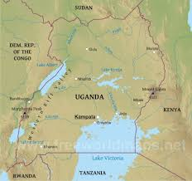

**Activity**

Children locate major physical features in Uganda

Trace the map of Uganda and name the physical features

**Exercise**

1. Name the physicalfeature that covers most parts of Uganda.

2. In which part of Uganda is Mount Elgon located?

**Formation of physical features**

**Formation of mountains**

There are two types of mountains in Uganda

These are:-

• Block /horst mountains

• Volcanic mountains

**Formation of Block Mountains /Rift valley**

* Block Mountains were formed when rocks underground developed cracks.
* Forces from underground caused some blocks to rise upwards and others to sink.
* These forces are known as tensional/compression forces.
* The raised blocks became block mountainswhile the sunk block became a rift valley.
* This process is known as faulting.

Faulting is the process by which cracks develop in the rock within the earth's crust as a result of tension and compression forces.

**Activity**

Children draw the diagrams showing the formation of Block Mountains.

**Diagram showing the formation of Block Mountains**

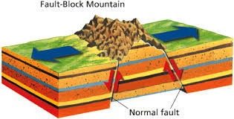

Other features which were formed as a result of faulting include; rift valleys, Rift valley

lakes.

**Activity**

Children draw, the diagram showing formation of rift valley.

**Diagram showing formation of the rift valleys**

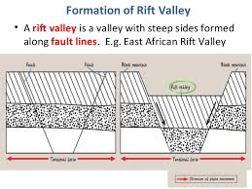

**Exercise**

1. How were Block Mountains formed'?

2. Mention one horst mountain in Uganda

3. Apart from Block Mountains, mention any feature which was formed as a result of faulting.

4. What is an escarpment?

5. Name two lakes found in the rift valley region of Uganda.

6 Mention two mountains that are located in the rift valley region of Uganda.

**Formation of volcanic mountains**

* This process by which volcanic mountains are formed is called volcanic activity or
* volcanicity.

**Volcanicity** is the process by which magma from underground is forced onto the earth surface.

* *A* volcanic mountain is formed when magma flows from the interior of the earth through a vent to the earth's surface,

When magma reaches the surface, it is known as lava.

* The forcing of magma onto the surface of the earth is known as an eruption

**What is Magma?**

* The molten rocks which comes out of the earth's interior during an eruption.

Lava

* Is magma which has cooled down on the earth's surface after eruption.

**Diagram showing the formation of volcanic mountains**

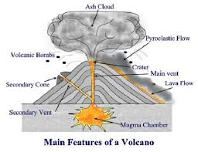

Examples of volcanic mountains in Uganda are:-

• Elgon

• Mufumbiro

• Agora

• Nangeya

• Moroto

At the top of a volcano, there is a depression called crater.

Examples of crater lakes in Uganda are:-

• Katwe

• Ngungu

• Karengyere

• Nyamunuka

• Nyamurangira

**Activity**

• Children watch a video clip on volcanic eruption.

• Children draw the diagram showing the formation of volcanic mountain.

**Types of volcanic mountains**

1. Active volcano - Is one which is erupting or shows signs of erupting at any time e.g. Mt. Mufumbiro.

2. A dormant volcano - Is one which last erupted many years ago and there are chances that it may or may not erupt again e.g. Mt. Moroto.

1. An extinct volcano / dead volcano - is one which last erupted many years ago and does not show any signs of erupting again e.g. Mt. Elgon.

**Exercise**

* State two dangers of a volcanic eruption.
* Mention one importance of a volcanic eruption to farmers.
* Name the materials that comes out during an eruption.
* Mention three types of volcanic mountain.

**Formation of lakes**

**New Words**

crater,depression,down warping,shallow

A lake is a big depression filled with water on the earth's surface.

**Types of lakes, examples and how they were formed.**

|  |  |  |  |
| --- | --- | --- | --- |
| **Type** | **Formation (Process)** | **Examples** | **Characteristics** |
| Depression / fresh water lakes | Down warping | L. Victoria, Kyoga, Opeta, Bisina, Kwania. Wamala. Kachira, Mburo | * They are shallow. * They are wide. * They have fresh water * They have both inlets and outlets * They have an irregular shape |
| Rift valley lakes | Faulting | L. Albert | * They have salty water * They are deep. * They are long and narrow. * They have inlets and outlets. |
| Crater lakes | Volcanic activity / volcanicity | L. Nyungu. L. Katwe, L. Nyamunuka | They are circular with steep sides. |
| Manmade lakes | Man's activity | Kabaka's lakes |  |
| Oxbow lakes | River meandering |  |  |
| Lava dammed lakes/volcanic | Volcanic activity | L. Bunyonyi L Mutanda. L Edward | They are very deep, |

**MOUNTAINS IN UGANDA**

|  |  |  |  |
| --- | --- | --- | --- |
| **MOUNTAIN** | **FORMATION** | **PEAK** | **PEOPLE** |
| Rwenzori | Faulting | **Margherita** | **Bamba**  **Bakonjo** |
| **Elgon** | **volcanicity** | **Wagagai** | **Bagisu**  **Sabiny** |
| **Moroto** | **volcanicity** | **Sodok** | **Karimojong** |
| **Mufumbiro** | **volcanicity** | **Muhavura** | **Bafumbira**  **Bakiga**  **Batwa**  **Bahororo** |

EXERCISE

1. Why is mtRwenzori snow caped?
2. Give two reasons why there no plants and animal life on top of mt.Rwenzori.
3. Why did H.M Stanley name Mt Rwenzori as mountain of the moon?
4. Why do people in Bundibugyo district rear donkeys?
5. What makes the construction of roads and railways difficult in Kabale district?
6. How are the Bagisu similar to the Baganda in terms of:

a. ethnicity

b. economic activity

7. Why does Arabica coffee grow well on the slopes of Mt. Elgon and Mufumbiro?

8. Why are the slopes of Mt. Elgon densely populated?

9.How does Mt. Elgon influence the climate of Mbale?

10. What is a plateau?

11. How was the plateau formed?

12. Name any two physical features found on a plateau.

**LAKES AND RIVERS IN UGANDA**

**A MAP OF UGANDA SHOWING LAKES AND RIVERS**



**Activity**

Children locate major lakes found in Uganda.

**LAKE VICTORIA**

• It was formed as a result of down warping. .

• L. Victoria is the biggest fresh water lake in Uganda and East Africa.

• It is shared by Uganda, Kenya and Tanzania,

Name the island districts found in Lake Victoria

• It is Kalangala district. ii) Buvuma

Name the major economic activities carried out by the people of Kalangala

(i) Fishing

(ii) Farming

iii) Tourism

iv) Lumbering

v) Charcoal burning.

**Problems faced by people of Kalangala.**

i) Poverty.

(ii) There is easy spread of water borne diseases.

(iii) Shortage of electricity.

(iv) Poor infrastructure.

(v) High rate of illiteracy.

**L. KYOGA**

It was formed as a result of down warping.

It is themost swampy lake in Uganda.

It is found in the centre of Uganda.

It is connected to L, Albert by Victoria Nile

Port Bukungu is found along this lake.

**Qn. Mention all the districts which share L. Kyoga.**

Why is L. Kyoga swampy?

• It is shallow

**LAKES, GEORGE AND EDWARD**

• They are joined by Kazinga channel.

• L.Edward is found in the western arm of the rift valley on the border of Uganda and DRC.

• It was formed by "volcanic activity.

• The Equator crosses L. George and L.Victoria .

Activities done at Kazinga channel

• Tourism .

• Transport

• Fishing

**L.ALBERT**

• Its traditional name is Mwitanzigye.

• It was named Albert by Sir Samuel Baker .

• It has a famous port called port Butiaba and Wanseko.

**Reasons why port Butiaba was built.**

* To link Uganda to DRC
* To promote transport
* To handle Uganda's imports and exports

**Activities carried out on inland ports**

* Trade
* Transport
* Tourism
* Fishing
* Fish processing

**L. MBURO**

* It is found in Kiruhura district.
* Part of L Mburo is a. national game park.

Importance of L. Mburo to Uganda's economy.

* Creates chances of employment.
* It earns foreign exchange through tourism.
* **EXERCISE**

**1. Name the tourist attraction found at Kazinga channel,**

Hippos

**2.Give the importance of inland ports of Uganda**

(i) They handle Uganda's imports and exports

(ii) They provide employment to people,

1. Mention the districts which share L.Kyoga
2. What shows that L.Kyoga is on a lower altitude than L.Victoria?
3. Give the difference between a seaport and an inland port.
4. Why is L.Kyoga shallow?

**RIVERS**

New Words

channel,canal,confluence,delta,estuary,tributary

* A river is a natural flow of water in a defined channel.
* Examples of rivers in Uganda are:- R. Nile, R. Katonga, R. Kafu. R, Achwa. R. Semliki

**Terms related to Rivers**

* Source:- It is a place where a river begins.
* Mouth:- It is where the river ends.
* Distributaries;- It is a small river that flows a way from a big river,
* Tributary:- It is a small river which flows into a big river.
* An estuary; It is where a river ends in a wide opening.
* A delta; It is where a river divides into small rivers before entering the sea or an ocean.
* A confluence; It is a point where two rivers meet to flow as one.

**Major Rivers in Uganda,**

**R. Nile**

* It is the longest river in Uganda. East Africa and Africa,
* Its local name is Kiira.
* R. Nile flows through south Sudan .Sudan and Egypt and it pours its waters into Mediterranean sea

R. Nile ends in a delta

.

There are several falls along R. Nile e.g. Bujagali falls, Murchison falls, Karuma falls and Kalagala falls.

**Exercise**

1. Why does R. Nile flow North wards?

Uganda central plateau is tilted towards the North. ; Northern Uganda is on a lower altitude than the south.

2. Name the first European explorer to see source of R. Nile.

John Speke.

3. Why isn't it correct to say that John Speke discovered the source of R.Nile.

The natives around the river had seen it before.

4. Give two economic importance of waterfalls.

* They help to generate hydro electricity.
* They attract tourists who bring income,

5. Why are some rivers not navigable (not used for transport).

* Presence of waterfalls and rapids.
* Some parts are narrow and shallow.
* Presence of big rocks.
* Floating vegetation.

6. How is R. Nile important to the industries of Uganda?

* It helps in the generation of hydro electricity
* Provides water for cooling down machineries in industries
* Provides water used as a raw material to industries .
* Provides fish to fish processing industries

7. Why are banks of R. Nile densely populated?

* Presence of fertile soils for agriculture
* Reliable rainfall for farming
* Presence of employment opportunities

Tributaries of R. Nile in Uganda.

* R. Kafu
* Achwa Section of the Nile.

**R. KATONGA**

* The source of R. Katanga is the swamps of L. George.
* It flows into L, Victoria.

**R. KAGERA**

* It has its source in Burundi highlands.
* It flows through Tanzania into L. Victoria.
* It marks a natural boundary between Uganda and Tanzania.

**R. ACHWA**

* It is a tributary of the Nile .
* It is the second longest river in Uganda.
* It is joined by R, Agago and Pager.
* It is the most extensively used river for irrigation in Uganda.

**R. SEMLIKI**

* It is found along the border of Uganda and DRC.
* It flows into L. Albert forming a simple delta at its end.
* R. Semiliki National Game park was established along this river.

**RIVER KAFU**

* It starts from a swamp inHoima in Western Uganda.
* R. Kafu flows into L. Kyoga.

**Activity**

Reading functional BK 5 SST

**Influence of physical features on climate**

**Exercise**

How do physical features influence climate?

* Mountains lead to the formation of relief rainfall.
* Lakes and rivers lead to the formation of convectional rainfall.
* The slopes of mountains experience low temperatures.

**Influence of physical features on vegetation.**

**How physical features influence vegetation?**

* Mountains with fertile soils and plenty of rainfall have thick vegetation .
* Swamps grow on the shores of lakes and livers.
* Thick forests grow at the lower parts of mountains and highlands.
* On the plateau, there is savannah grassland.

**How physical features influence animals and birds?**

* Most small animals are found on the plateau because it has plenty of short grass for them.
* Animals e.g. fish, crocodile, hippos live in lakes and rivers.
* Mountain gorillas live in mountain areas with bamboo forests.
* Some birds like ducks and geese are attracted to places with plenty of water.
* Swamps are homes to some birds and animals.

**How physical features influence human beings?**

* People settle in highlands because they have fertile soils and reliable rainfall.
* Humans also settle around lakes and rivers to carry out fishing.
* Valleys have few people because they have more vectors.
* Plateaus attract more farmers and industries since they are flat.

**Importance of physical features**

Mountains and highlands

Importance of mountains and highlands

* They are a source of some rivers.
* They help in rainfall formation.
* They attract tourists who bring income.
* They have cool temperature for settlement.
* They have rich mineral deposits e.g. limestone from Tororo and Hima Copper from Mt. Rwenzori
* They form boundaries between countries.
* Volcanic mountains have fertile soils for farming ,
* Forests growing on mountains provide trees for timber.

**Plateau**

**New words**

Raised,settlement,construction,tourists,mineral deposits

**Activities done on plateau**

• Tourism

• Mining

• Industrialization

• Lumbering

• Construction of settlements

Problems faced by people who live on the plateau.

• Soil erosion

• Floods

• Crop pests and diseases

EXERCISE

1. State the economic importance of mountains and highlands.
2. How do hills and mountains promote transport?
3. What is the political importance of mountains?
4. How have the people of Kapchorwa solved the problem of poor transport?

**Importance of Plateau,**

* They have fertile soils for farming
* It is good for construction of roads, industries and human settlement.
* It has plenty of glass for grazing animals.
* Attracts tourists in natural parks
* They have mineral deposits like sand

**Lakes and rivers**

**Importance of Lakes and rivers**

* They provide water for both industrial and home use.
* They provide running water which is used in the generation of hydro electricity.
* They are a source of minerals like salt from L. Katwe and oil from L. Albert.
* They provide water for irrigation.
* They attract tourists.
* They are grounds for recreation like swimming and rafting to holiday makers and tourists.
* They are used for transport and communication.
* They help in the formation of convectional rainfall.
* They are a source of fish.
* They mark boundaries between places.

**The rift valley**

**Importance of the rift valley.**

* It is a source of minerals.
* It has many lakes and rivers which provide fish.
* It is good for animal grazing.
* It can be used for game conservation e.g. Queen Elizabeth NGP.
* Attracts tourists who bring income.
* The rift valley floor has fertile soil.

**EXERCISE**

1. Name different types of fish found in the lakes of Uganda.

1. How do lakes and rivers promote agriculture?
2. Give anyone economic importance of a rift valley

**Mountains and highlands**

**Problems caused by mountains and highlands in Uganda.**

* Soil erosion is common.
* They make construction of roads and railway expensive and difficult.
* Landslides are common during heavy rains.
* Active volcanoes can easily erupt.
* Active volcanoes are prone to earthquakes.

**Solutions to problems caused by mountains and highlands**

**People should be sensitized to:-**

* Use animal transport,
* Use terraces to control soil erosion.
* Use ox - ploughing where tractors cannot work.
* Avoid cutting trees from mountains.
* Plant more trees to control landslides.
* The government should resettle people affected by landslides to safer places.

**problems caused by the Plateau**

* Some areas of the plateau have poor soils.
* Some areas of the plateau receive low rainfall.
* Some parts of the plateau are infested with disease vectors like tsetse fly,
* The plateau has many valleys and wetlands which become flooded during heavy rains.
* Some wild animals which live in the plateau area can kill people and destroy properly,

**Solutions to problems caused by plateau**

* Apply fertilizers in areas with poor soils
* Carry out irrigation farming in areas which receive low rainfall.
* Use tsetse fly traps to destroy tsetse flies.

**Problems caused by Lakes and rivers**

* People can drown in lakes and rivers.
* They are breeding places for disease vectors.
* There is flooding during heavy rains.
* Some of the water animals are dangerous to human life,

**Solutions to problems caused by Lakes and rivers**

* Drinking water should be boiled or treated to avoid water related diseases.
* Avoid cultivating near rivers to control floods.
* Flood banks should be built to control floods.
* Avoid overloading boats.
* Life jackets should be used while sailing or swimming.

**Problems caused by Rift valley,**

* The escarpments make the construction of roads (makes transport difficult).
* Some rift valley areas he in the rain shadow thus receiving little rainfall.
* Rift valley lakes have few fish species because they are deep.
* Rift valley lakes have wild animals like crocodile and hippos which are dangerous to people.
* Floods are common.

**Solutions**

* Constructing winding roads.
* Practising irrigation farming.

**Exercise**

1. Identify any two water borne diseases.

2. Identify problems brought about by lakes and rivers.

3. Identify activities done by people on mountain slopes.

**TOPIC 3:**

**THE CLIMATE OF UGANDA**

**New Words**

**weather,instruments,record,climate,tropical,equatorial**

**Revision work on weather(Oral discussion)**

1. What is weather?

2. Mention four elements of weather.

3. Suggest the element of weather which favours human settlement.

4. What is a weather station?

5. State the instruments used for measuring the following weather elements

a) Temperature

b) Rainfall

c) Wind direction

d) Speed of wind

6. Identify the types of weather.

**Activity**

Children identify weather instruments and their function,

**CLIMATE**

Climate is the average weather conditions of places recorded for a long period of time.

Climatic regions of Uganda

Uganda has three major climatic regions and these are:

1. Equatorial climatic region (wet regions)

2. Semi - arid climatic region (dry)

3. Tropical climatic region (.hot)

4. Montane climatic region (wet)

Activity

**Draw a map of Uganda showing climatic regions**

1. How can one describe Equatorial climate,

2. Why is Robusta coffee grown in Buganda region and not in Karamoja?

3. Why do we have many tropical rain forests in Equatorial region

Equatorial climatic region

It is described as hot and wet throughout the year.

It is experienced around L Victoria and in highlands.

It receives heavy rainfall throughout the year

It receives convectional rainfall

Questions

1. Name the type of rainfall received around L.Victoria.
2. Give two characteristics of the above rainfall.
3. State any two factors which cause convectional rainfall.
4. How can one describe Equatorial climate,
5. Why is Robusta coffee grown in Buganda region and not in Karamoja?

6 . Why do we have many tropical rain forests in Equatorial region

**Semi- arid (semi desert) climate**

* It receives little rainfall.
* It is hot and dry most of the year.
* Areas which experience this type of climate are Kotido, Moroto, Nakapiripirit, Kaabong, Ankole - Masaka dry corridor in Kiruhura district.

**Characteristics of semi — arid climate**

* Very little rainfall is received.
* They have very low humidity due to absence of vegetation cover and water bodies.
* They experience very high temperatures.
* The skies are clear during day and night.
* The nights are usually cold

**Tropical Climate**

* It is described as dry and wet.
* Most parts of Uganda receive this type of climate because Uganda lies within the tropics.
* Areas which receive this type of climate are;-Mbarara, Rakai, Mpigi, Wakiso, Nebbi, Arua.

**activity**

Children draw a graph showing tropical climate

**Mountain / Montane climate**

It is experienced in highlands of South western Uganda, slopes of Mt. Elgon and Mt. Rwenzori.

It has cool temperatures and high rainfall.

Activities done in this type of climate are ;

* Mining
* Farming
* Tourism

**Influence of physical features on climate.**

How highlands influence climate.

* Highlands influence the formation of rain.
* The rain formed in highlands is called relief rainfall or orographic rainfall,
* Places at a higher altitude are cooler than places at a lower altitude.

**Formation of relief rainfall**

Diagram showing formation of relief rainfall

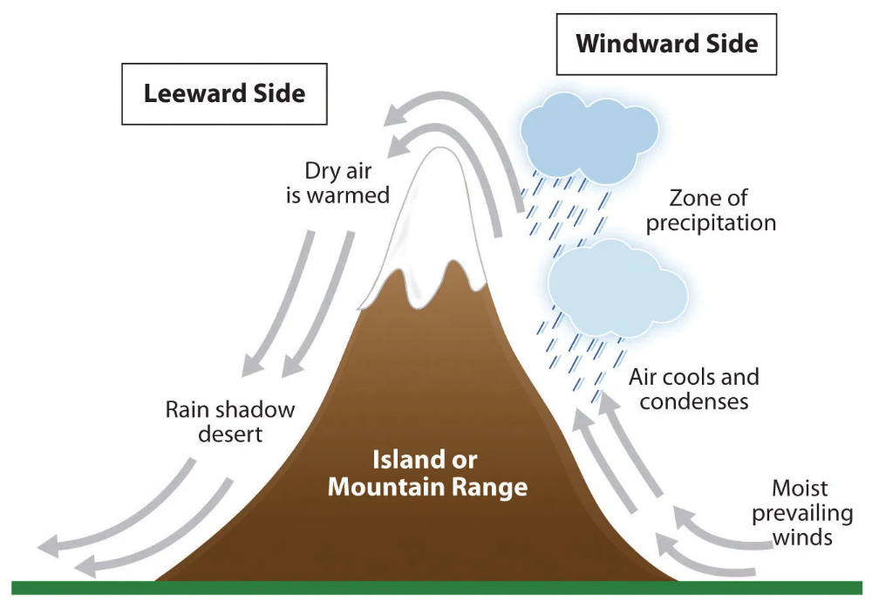

**Activity**

Children will draw the diagram showing the formation of relief rainfall.

**Exercise**

a. Why does the windward side of the mountain receive more rainfall?

1. Why does the leeward side of the mountain receive little rainfall?

c. Suggest two economic activities done by people on the windward side?

d. State the major economic activity don by people on the wind ward side?

1. Mention the districts which receive the type of rainfall above.

**How do Water bodies influence climate?**

* Water bodies such as oceans, seas, lakes, rivers help in rain formation.
* This type of rainfall is called convectional rainfall.

Diagram showing formation of convectional rainfall

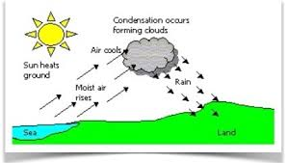

**Exercise**

1. Name the processes involved in the formation of convectional rainfall

2. Give any two areas where the above rainfall is received.

3. State two characteristics of convectional rainfall.

4. What is the use of the sun during the process of rain formation.

5. What happens to the rising vapour when it cools?

Diagram showing formation of cyclonic rainfall

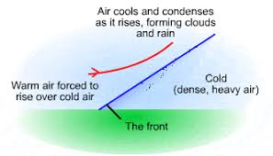

Two winds warm moist air and cold dry wind meet at a front and the strongest wind (cold wind! pushes (he weak one (warm moist air). The weak wind (moist air) rises condenses, cools and them forms clouds and later rain.

Exercise

* + 1. How do plains influence climate?
    2. Which type of rainfall is received in plains?
    3. What is another name for cyclonic rainfall?

**Activity**

Children rend functional SSt BK 5 pg 44

**Factors influencing the climate of Uganda.**

* Latitude
* Altitude
* Nature of vegetation
* Human activities
* Distance from water bodies
* Prevailing winds

**a) Altitude**

* Altitude is the height above sea level.
* It is measured by altimeter
* Places at a higher altitude receive more rainfall than places at a lower altitude.
* Places at a higher altitude are cooler than places at a lower altitude.

Why is Kisoro cooler than Kampala?

Kisoro is at a lower altitude than Kampala.

b) Distance from water bodies

Places near water bodies receive a lot of rainfall.

c) Latitude (Distance from, the equator)

Places near the equator experience high temperatures than places far away from the equator hence receiving a lot of rainfall due to high evaporation and transpiration rates.

d) Human activities

A forestation, re- forestation, agro-forestry increase chances of rain while deforestation reduces chances of rainfall.

e) Nature of vegetation.

Places that have thick forests receive plenty of rainfall while places with little or no ;vegetation are very dry.

**Influence of climate on human activities.**

**Activity**

Children read functional SSt BK 5 pg 46747

Human activities influenced by climate include;- , :

* Farming
* Afforestation
* Pit sawing or lumbering
* Housing

**How does climate influence farmers' activities?**

* People living in wet areas carry out crop farming while those in dry areas carry out cattle keeping.

Activity

**Draw a map of Uganda showing major cash crops**

**Exercise**

1. **What are cash crops?**
2. **What are non traditional cash crops?**
3. **Give two examples of non traditional cash crops.**
4. **Name the cash crop grown in West Nile.**

**Cattle keeping:**

**People in Uganda who practice nomadic postoralism are;-**

* Karimojongs
* Bahima

**Why do the Karamojong move from one place to another?**

* To look for water and pasture for their animals.

**Problems faced by Karamojongs in their activity**

* Cattle diseases.
* Long, drought seasons,
* Shortage of pasture and water.
* Cattle rustling.

**Exercise**

**1.State ways the government can help the Karamojongs to live a settled life.**

* By building valley dams.
* Educating them to keep a manageable number of cattle.
* Encouraging them to practice mixed farming.
* Growing drought resistant pastures. x *}*

**2. How has the government tried to solve the problem of water in drier parts of** Uganda?

* By building valley dams
* By drilling boreholes
* By using tanks to harvest rain water

**3. Why is North eastern Uganda is sparsely populated?**

It is a semi - desert / it is dry / receives little rainfall.

Nomadic pastoralism is the movement of people with their animals from one place to another looking for water and pasture.

**The effects of drought can be reduced by:-**

* Using water to irrigate gardens.
* Practicing rotational grazing to protect the pastures.
* Constructing valley dams and boreholes.
* Moving to areas least effect by drought.
* Planting trees in dry areas to modify climate.
* Avoid overstocking and over grazing.

**EXERCISE**

1. How does climate affect human activities?

2. How does climate affect the way people build houses?

3. How does climate affect people's way of dressing?

1. How does climate affect the type of crops people grow?

**TOPIC 4:**

**VEGETATION IN UGANDA**

**New Words**vegetation,natural,planted,grassland,savanna,wetland

Children move around the school compound identifying the vegetation.

**What is vegetation?**

Vegetation is the plant cover of an area.

**Types of vegetation**

* Natural vegetation
* Planted vegetation

What is natural vegetation'?

This is the plant cover of an area that grows on its own.

Examples of natural vegetation include;-

* Forests
* Swamps
* Grasslands
* Shrubs

What is planted vegetation?

This is the plant cover of an area that is grown by people.

Elements of vegetation

* trees
* Grass
* Flowers
* Crops

Examples of planted forests are Lendu, Mafuga, Magamaga, Types of natural vegetation is Uganda.

Types of natural vegetation in Uganda

i. Equatorial rain forests

ii. Savanna grassland

iii. Mountain vegetation

iv. Semi - arid vegetation

v. Swamp / wetland vegetation

Activity

**Draw a map showing vegetation zones in Uganda**

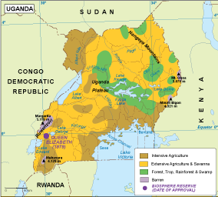

**Exercise**

1. **What name is given to the plant life of an area?**
2. **Which type of natural vegetation covers most parts of Uganda?**
3. **Give two examples of planted vegetation.**

Equatorial rainforests.

* These are .forests which grow in areas which receive heavy rainfall
* Examples of trees found in Equatorial rainfall include:-

1. Mahogany

2. Muvule

3. African walnut

4. Ebony

5. Rosewood

Examples of natural forests found in Uganda

|  |  |
| --- | --- |
| **Name** | **District** |
| Mabira | Buikwe |
| Bugoma | Hoima |
| Budongo | Masindi / Hoima |
| maramagambo, Kalinzuand Kasyoha - Kitoni | Rubirizi/Hoima |
| Rwenzori | Kasese |
| Itwara. | Kabarole |
| Zoka and Wicre | Adjuman |
| Bwindi impenetrable | Kanungu/Kabale |
| Rwenzori | Kasese |
| Itwara | Kabarole |
| Zoka. and Wicre | Adjuman |
| Bwindi lmpenetratable | Kanungu/Kabale |
| Marabigambo | Rakai |

**Activity.**

Children will draw map of Uganda showing forests.

Characteristics of Equatorial (rain forests)

* They are ever green with broad leaves.
* They have thick undergrowth.
* They receive heavy rainfall,
* There high humidity over them.
* They experience high temperatures.
* Tree species contain buttress roots.
* Trees form a canopy
* Trees are very tall,

Examples of planted forests in Uganda.

* Lendu in Nebbi district
* Mafuga in Rukungiri
* Bugamba in Mbarara
* Nyabyeya near Budongo forest
* Katuugo near Nakasongola
* Magamaga in Iganga
* Abera in Gulu

Products got from soft wood trees

Paper, match sticks, rulers, pencils, soft plywood, wood carvings, tool handles, musical instruments.

Examples of soft wood trees include:-

* Eucalyptus, pines, conifers, camphor and cypress.

Activity

Draw a map of Uganda showing forests

**Savanna vegetation.**

It covers the biggest part of Uganda's total area.

The two types of savanna vegetation are;-

i) Savanna grasslands.

ii) Savanna woodlands.

a) Savanna grasslands is mainly grass with scattered trees.

The tree species are mainly acacia.

It is well developed in NE and in the rift valley floor of western Uganda.

b) Savanna woodlands

This comprises of a continuous cover of short grass.

They shed their leaves during dry season.

**Characteristics of savanna vegetation**

* They have short tree species
* Trees have small compound leaves
* Trees have a thick barks
* Trees shed their leaves to reduce transpiration.
* Most trees have tap roots

Exercise

1. Why do trees in dry areas of Uganda have small compound leaves?
2. Why do trees in dry areas have tap roots?
3. Give one reason why trees shed off their leaves in dry season.

**Importance of Savanna vegetation.**

* They provide pasture for animals.
* They act as a natural habitat for animals.
* Grasslands provide grass for thatching houses.
* Savanna, land has suitable conditions for growing crops such as simsim, cotton, maize, millet, groundnuts tobacco.

**Qn. Why are most game parks located in the savanna grasslands?**

**Mountain/Montane vegetation.**

**This vegetation is found in mountainous areas**

* The vegetation changes with altitude,
* At the foot of the mountain, there is tropical grassland.
* From 1500m to 3000m. there are forests (ever green)
* Above 3000m. there are bamboo forests,
* They are followed by small plants called Moorland and heath,
* Above the moorland and heath, there is snow and bare rock.
* **Activity**
* Draw an illustrational diagram showing mountain vegetation.

END

Swamps//wetland

A swamp is a water logged area with vegetation.

**Importance of swamps.**

* They are sources of raw materials for crafts.
* They are a source offish e.g. mudfish.
* They help in rain formation.
* They help to filter dirty water
* Home for wild animals.

**ACTIVITY**

Study the vegetation map of Uganda in your atlas and identify different types of vegetation,

Exercise

1. Name the most swampy lake in Uganda.
2. Why is it dangerous to settle in swampy areas?
3. Mention any two crops grown in swampy areas.
4. How are swamps useful to people?
5. What factors favour the growth of the above crops in swampy areas?

**Factors that influence vegetation distribution in Uganda**

**1. Rainfall**

Areas that receive plenty of rainfall have thick vegetation cover.

**2. Fertile Soils**

Places with fertile soils and reliable rainfall have thick vegetation compared to those with poor and infertile soils.

**3. Altitude**

Places at a higher altitude have thicker vegetation compared to places at a lower altitude.

**4. Drainage**

Areas which are water logged support swamp vegetation.

***5.* Human activities**

People change vegetation by planting trees, grasses, crops and flowers, people cut down treeand destroy vegetation cover.

**6.Government policy**

The government encourages people to plant trees in their homes.

**7.Land forms**

The mountain side that receives much rainfall has thick vegetation compared to the leewardside.

**Exercise**

1. Identity the factors which affect vegetation distribution in. Uganda.

2. How do human activities affect the vegetation of an area?

3. How can people improve the vegetation of an area?

**How vegetation influences human activities.**

Human activities in savanna grass land.

Tourism

Crop farming

Cattle keeping

**Human activities in rainforest**

* Tourism.
* Lumbering
* farming

**Human activities in mountain vegetation.**

* There is settlement on the foot of mountains and hills.
* There is crop farming clue to fertile soils and reliable rainfall,
* Quarrying is carried out since mountains have hard rocks,
* There is tourism due to game parks.

**Human activities in swampy vegetation,**

* People carry out brick making.
* Farming is earned out in swampy areas.
* There is fish farming.
* There is craft and furniture making activities.

**Uses of Vegetation:**

* Forests provide firewood and charcoal :
* Forests provide timber
* Forests provide electric poles
* Savanna grasslands provide pasture for domestic and wild animals.
* Vegetation helps in rainfall formation
* Vegetation is a source of food.
* Vegetation is a source of beauty and decoration e.g. flowers.
* Vegetation controls soil erosion
* Vegetation is a source of herbal medicine.
* It is home for wildlife.

**Ways of conserving vegetation**

* Through afforestation.
* Through re-afforestation.
* Through establishing game parks and game reserves.
* Through controlled harvesting of trees.
* Through agro-forestry.
* By planting grass.
* By making hedges.
* Through fencing off forests.
* Thro ugh rural electrification.
* By using alternative fuels e.g. bio gas.

**Human activities that negatively affect vegetation**

* Cutting down trees on a large scale.
* Buck making and sand mining,
* *S*wamp drainage.
* Over grazing.
* Bush burning,
* Dumping industrial and domestic wastes in swamps and forests.

**Human activities ..that positively affect vegetation**

* Afforestation
* Reafforestation
* Avoid bush burning
* Agro forestry
* Avoiding swamp drainage

**Activity**

Caring for trees, grasses, and flowers in the school compound by watering them,

**Relationship between vegetation and population distribution**

* Few people settle in forested areas.
* Few people settle near swamps.
* Few people settle in semi arid-vegetation.
* Few people settle in savanna woodlands.

**Questions**

* 1 Mention the ways you can be involved to conserve forests.
* 2. Give two reasons why few people settle in forested areas.
* 3 Name the district in Uganda found in dry savanna..
* 4. Why are there very few people in Karamojaregion.
* 5.Why is it not good to settle in swamps.
* 6.Give one reason why lake shores are densely populated.

**TOPIC 5:**

**NATURAL RESOURCES IN UGANDA**

**New words. renewable,non renewable,resources,minerals,gazetted**

What are natural resources?

These are things provided by nature that people use to meet their needs.

**Types of natural resources**

Renewable and non renewable resources

Renewable resources are resources which can be replaced after use.

eg people,land.etc.

Non renewable resources are resources which cannot be replaced after use.

eg Minerals.

**Examples of natural resources**

* Forests
* Land
* People
* Minerals
* Climate
* Air
* Sun.
* Water
* Vegetation
* Animals.

Activity

Children locate different natural resources on the map of Uganda.

**Importance of Natural resources**

**1. Land**

**Uses of land as a natural resource**

* It helps us to grow crops
* It is used for settlement
* It is used for rearing livestock.
* It is used for establishing industries
* Laud is a source of minerals.
* It is sold for money

**Problems facing land as a natural resource.**

* Soil erosion
* Dumping wastes on land (land pollution)
* Poor fanning methods
* Landslides

**Care for land as a natural resource.**

* Proper land use.
* Practice afforestation and reafforestation.
* Promote conservation of forests and water sources,
* Avoid pollution by not dumping unsafe materials in the soil,
* Promote irrigation fanning.

**MINERAL RESOURCES**

* Minerals are valuable materials in the ground.

**Examples of minerals**

* Phosphates,
* Copper,
* Gold,
* Salt,
* Crude oil.
* Limestone.

|  |  |  |  |
| --- | --- | --- | --- |
| **Minerals** | **Place where it is mined** | **Methods of mining** | **Product** |
| Copper | Kilembe, Kasese | Deep cast | Coins  Electric wires  Jet engines |
| Limestone | Osukuru Hills, Tororo  (Hima) Kasese | Open cast | Cement  Lime |
| Cobalt | Kasese | Open Cast | Bangles |
| Phosphates | Tororo | Deep casting | Artificial fertilizers |
| Crude Oil | Lake Albert | Drilling | Diesel  Petrol  paraffin |
| Gold | Moroto, Mbarara, Kitgum | Alluvial mining | Medals  Jewellery |

**Importance of mining industry**

* Provides raw materials for industries.
* Increases job opportunities.
* Earns foreign exchange,
* Leads to industrialization.
* Mining companies pay taxes to the government.

**Exercise**

**Reasons why the mining industry is-not well developed in Uganda**

* Shortage of capital
* Low technology.
* Poor machinery.
* Insecurity in some areas.
* Shortage of skilled labour.
* Poor transport system

**Problems faced by miners**

* Death of people in case the mines collapse.
* Flooding of mines.

**-Disadvantages of mining**

i).It 'lends to land degradation.

ii) It leads to displacement of people,

iii) It leads to pollution.

**Activity**

**Draw a map of Uganda showing minerals**

**Water sources; lakes and rivers**.

* *A* large part of Uganda is covered by lakes, rivers arid springs
* Springs are seasonal water masses and disappear during the dry season

**Importance of water as a natural resource.**

* It is used both in homes and. industries as raw material.
* It .is used in the generation of hydro electricity.
* It is used for irrigation of crops.
* It is used for transportation.
* It is a source offish.
* Helps in the formation, of convectional rainfall.
* It is used *in* industries as a law material and for cooling machines.
* Used for tourism.

**Problems faced by water as a natural resource.**

* Pollution
* Overusing water in lakes and rivers.
* Drought

**Caring for water as a natural resource .**

* Avoid pollution by not dumping unsafe materials in water.
* Avoid overusing in lakes and rivers.
* Cleaning water sources.

**People**

* They provide labour to different sectors of the economy,

**Problems facing people as anatural resource.**

* Diseases :
* Poverty
* Unemployment
* Wars.
* Low salaries

**Caring for people as a natural resource.**

* Encourage family planning to control population growth.
* Provide good feeding, good health and education to the people.
* Paying workers well.

**Climate**

It influences our way of living and all the activities we do.

Importance of climate as a natural resource,

* Rainfall and temperature favour the growing of crops and the rearing of animals.
* Supports all human and animal and plants life.

**Vegetation**

Uganda has planted and natural vegetation

**Importance of vegetation as a natural resource.**

* It is a source of food.
* They help in rain formation.
* They are a source of local medicine.
* They provide raw materials for construction of industries.
* They control soil erosion.
* They are a source of fuel.
* They are a source of income.

**Problems facing vegetation as a natural resource**

* Deforestation
* Swamp drainage
* Overgrazing
* Over cultivation
* Pollution e.g. chemicals, polythene bags etc

**Caring for vegetation as a natural resource**

* Promote conservation of wildlife.
* Avoid swamp drainage
* Promote irrigation fanning
* Afforestation
* Re afforestation

**Activity**

**Discussion with the teacher ways we care for the vegetation in our school.**

**Exercise**

* State ways we care for vegetation as a natural resource.
* How has vegetation been destroyed in our district?
* How does pollution affect vegetation.

**Animals**

There are two types of animals namely domestic and wild animals.

Importance of animals as a natural resource

* Some animals are a source of food.
* Some animals act as tourist attractions.
* Some animals are a source of income
* Some animals act us pets.
* Some animals provide employment opportunities e.g. veterinary officers.
* Some animals are used for transport.

**Problems faced by animals**

* There is poaching
* Long drought seasons
* Shortage of water and pasture
* Outbreak of animal diseases.
* Insecurity in some areas.

**Caring for animals, as a natural resource**

* Providing water and pasture to animals.
* Providing shelter for animals.

**Domestic animals**

* The animals that stay in the house are called pets e.g. dogs and cats.
* People rear cattle, sheep, camels, goats and donkeys as their livestock,

**Wild animals**

**Types/Kinds of wild animals**

* Herbivorous which feed on vegetables e.g. Zebra, giraffe, antelope
* Carnivorous which feed on fresh; Lions, hyenas, Leopards and Tigers
* Omnivorous which feed on both vegetation and flesh
* Wild animals like elephants, giraffes, baboons. Monkeys, Chimpanzees and gorillas live in rain forests,
* Wild animals like Zebras, leopards, hyenas, kobs, tigers, lions, snakes, hares live in tropical grasslands.
* Other animals e.g. fish, crocodiles, hippos, frogs, toads and tortoise live near water or swamps.
* Animals such as camels, cheetahs, squirrels live in semi desert: areas.
* These animals are protected in game parks.

**Game parks**

Game parks are gazetted areas for the preservation of wild life.

Reasons why there are many game parks in savanna vegetation

* There is plenty of pasture
* It is a habitat for wild animals
* Has favourable climate for animals

**Advantages of game parks**

* They attract tourists who bring income
* Provide chances of employment
* They preserve wildlife *for* future general ions
* They are for study purposes.

National game parks in Uganda

**National parks**

Bwindi Impenetrable

b) Kibale

c) Kidepo

d) Lake Mburo

e) Mgahinga Gorilla

f) Mt, Elgon

g) Murchison falls

h) Rwenzori

i) Semliki

The largest game park in Uganda is Murchison falls National Park.

**Game reserves**

* A game reserve is an area where wildlife is protected by law.
* In a game reserve permission can be given for hunting but. in a game park no hunting is allowed,

Activity

Draw a map of Uganda showing game parks.

**Tourist attractions in Uganda**

These include: -

* Game parks
* Mountain sceneries
* Forests
* Historical sites
* Cultural sites
* Climate
* Insecurity in some areas
* Shortage of accommodation
* Animal diseases
* Poaching
* Encroachment

Ways the government can improve on tourism industry

* Improve on security
* Improve on accommodation by building more hotels and lodges
* Introduce more animal species
* Protect the existing game parks

**Dangers of Poaching**

It reduces wild animals in game parks.

**Exercise**

In which way does the build of hotels promote tourism industry?

* Provide accommodation services to the tourists
* Provides transport to tourists

Why do you think a tourist who comes to Uganda is given a map of Uganda?

* To locate tourist attraction centres.
* To identify the tourist attraction centre,

**END**